🔵 What is a Web App?
A Web App in Azure is a service used to host websites, APIs, and web applications without managing servers.
(Example: host your Python, .NET, Node.js app.)

🔵 What is an App Service Plan?
An App Service Plan provides the CPU, RAM, storage, and features needed for the Web App to run.
Think of it like:
👉 Web App = Application
👉 App Service Plan = Machine/Server where the app runs

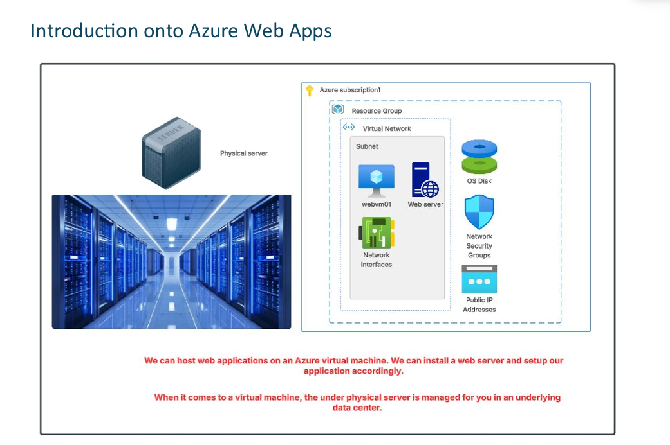

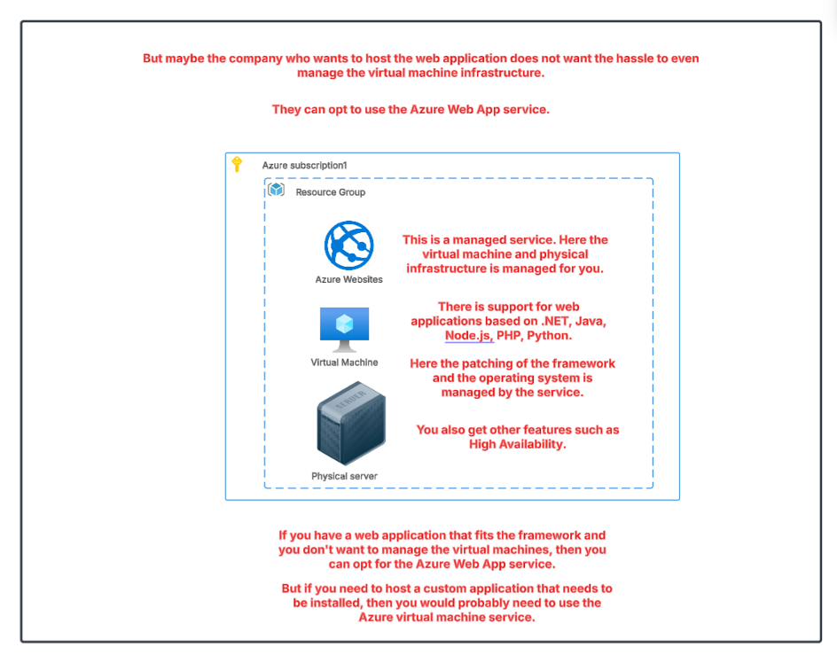
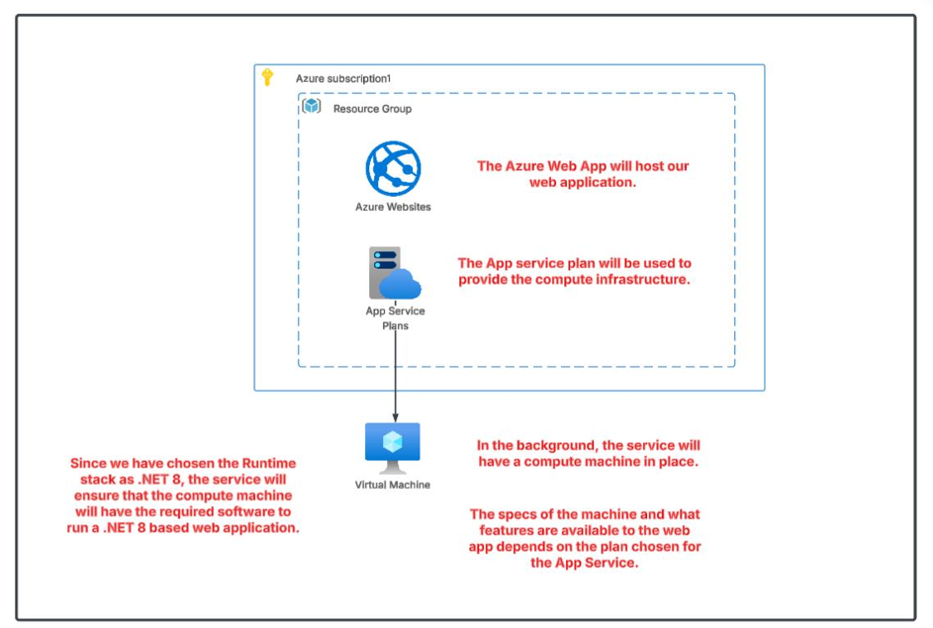

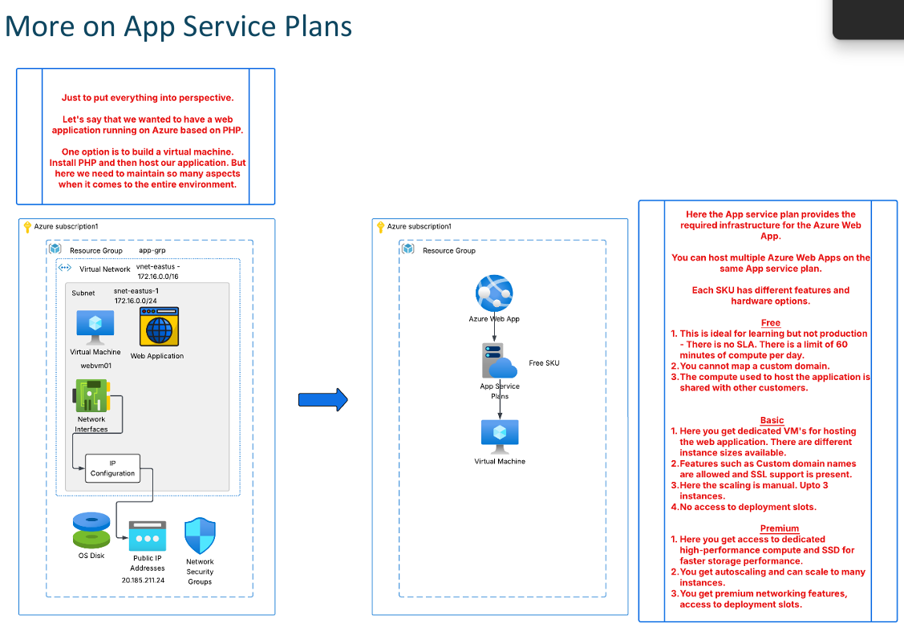
🔵 What Is an App Service Plan?
An App Service Plan in Azure defines the compute resources (CPU, RAM, Storage) that your Web App, API App, or Function App will run on.
It controls:
- How much CPU/RAM your app gets
- How many instances you can scale to
- What features you can use (custom domain, SSL, autoscaling, backups, VNet integration, etc.)
- The price you pay (Free → Premium)

📌 Tiers of App Service Plans
🟢 1. Free (F1)
✔ Best for learning, testing, POC
✔ Shared compute resources
✔ No custom domain
✔ No SSL certificate
✔ Limited storage and performance
✔ No SLA
✔ No scaling
Use case: Small demo apps, practice, students.

🔵 2. Basic (B1, B2, B3)
✔ Dedicated VM-like environment
✔ Custom domain support
✔ Manual scaling (up to limited instances)
✔ SLA available
✔ 10 GB Storage
✔ No auto-scaling
✔ No staging slots
Use case: Small production apps with low traffic.

🟡 3. Standard (S1, S2, S3)
✔ Everything in Basic +
✔ Auto-scaling
✔ Multiple staging slots (for deployment: slot swap)
✔ Daily backup support
✔ Better performance (more CPU/RAM)
✔ Traffic Manager support
✔ VNet integration
Use case: Medium traffic production apps, business apps.

🔴 4. Premium (P1v2, P2v2, P3v2, P1v3… etc.)
✔ Best performance + high scalability
✔ SSD-based premium storage
✔ More staging slots
✔ Advanced auto-scale
✔ High-performance VM sizes
✔ Isolated instances
✔ Better SLA
✔ Supports enterprise apps
Use case: High-traffic, mission-critical applications requiring high performance.

To change the plan:-
Go to the web app-left side-app service plan-scale up for upgrade and scale out means SCALING THE WEB APP.

1)how to create the web app:-the name of web app will become your domain name .
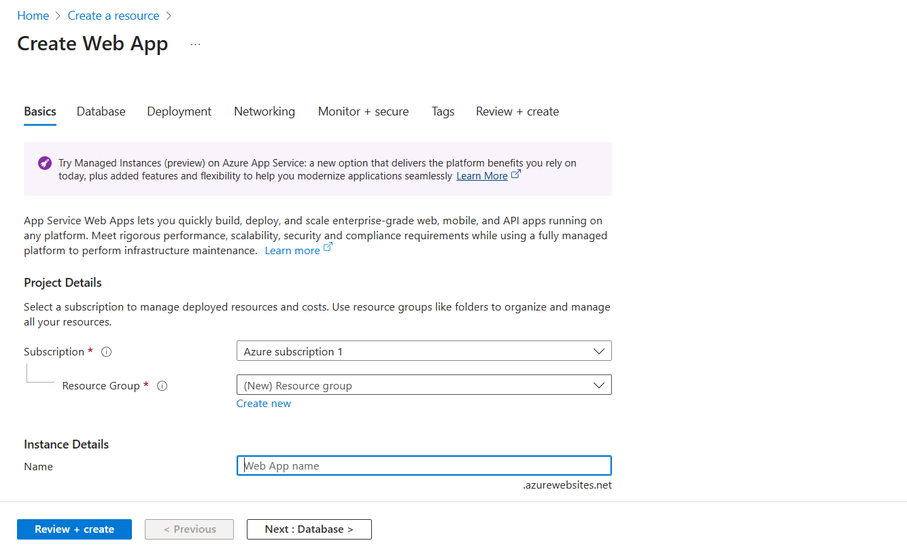

U can add container and code also.the runtime stack means which language java,python here we used php.
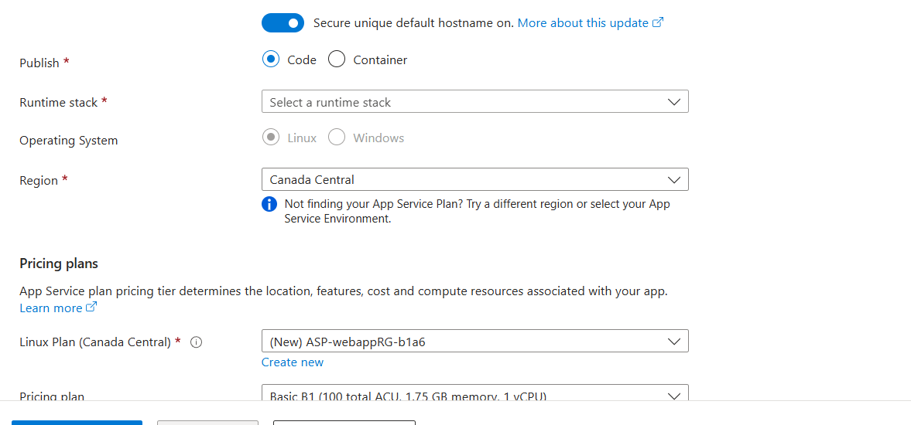

U can attach it with database.
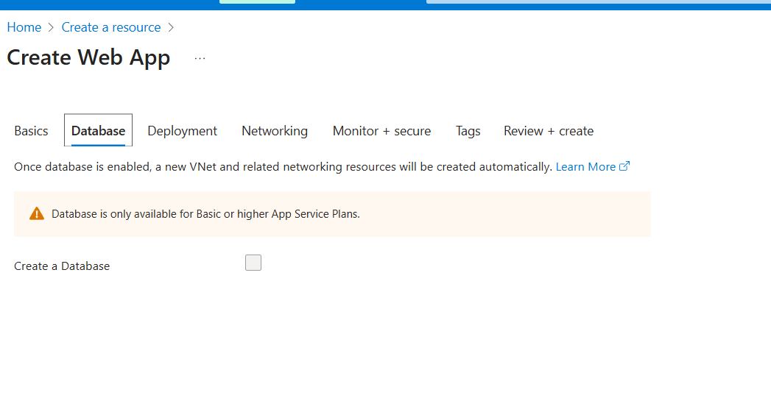
U can get code from github.
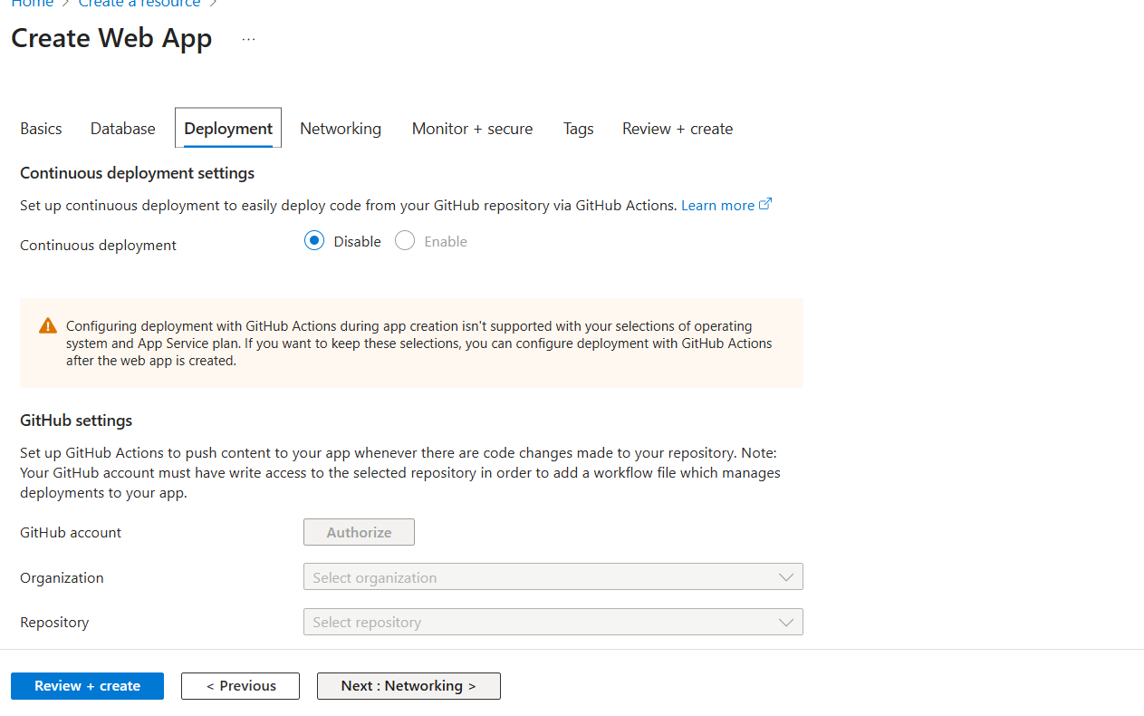

U can use app insight that works like monitoring tool.
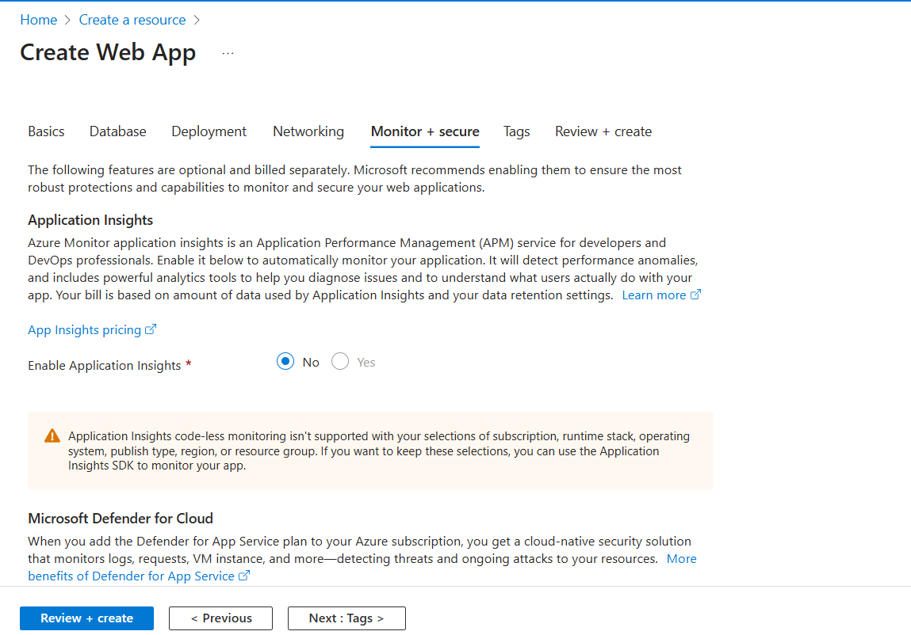
After creating the web app u can login to that using below image.and add below code to deplay simple website. And using that domain name u can browse the website.
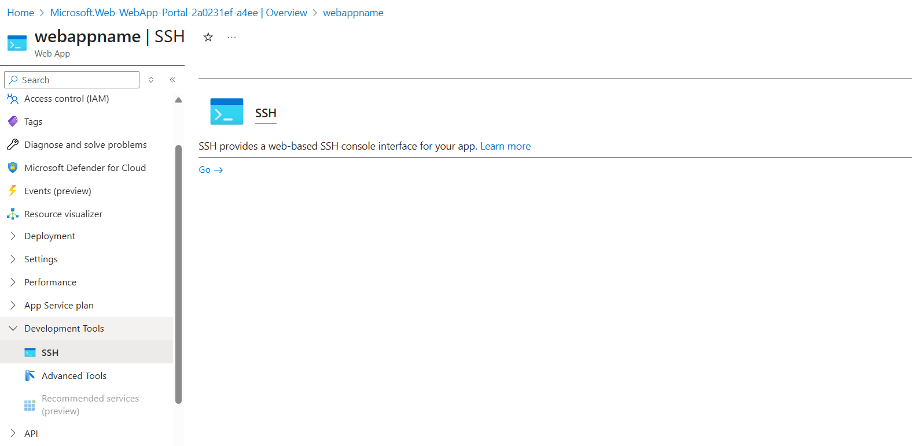.
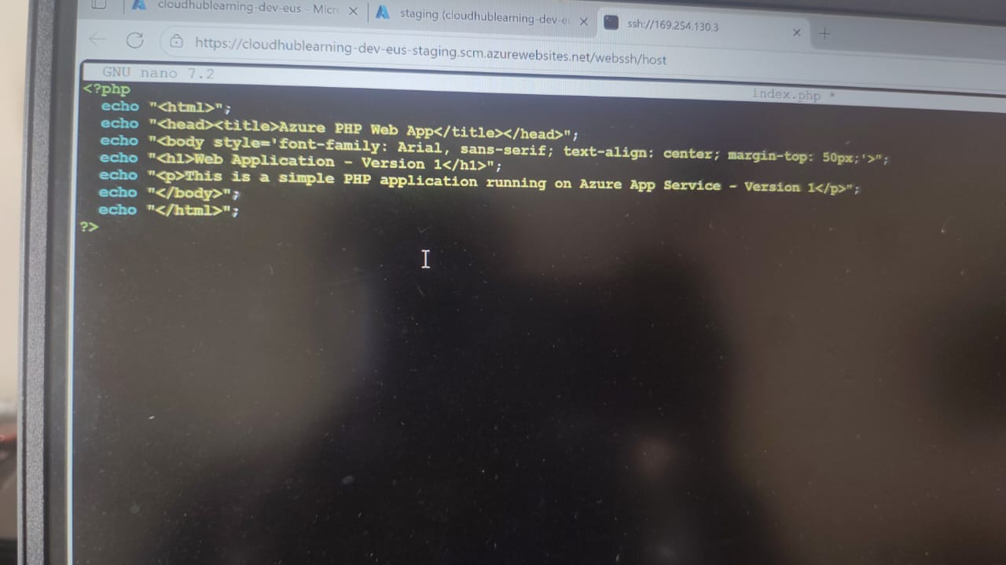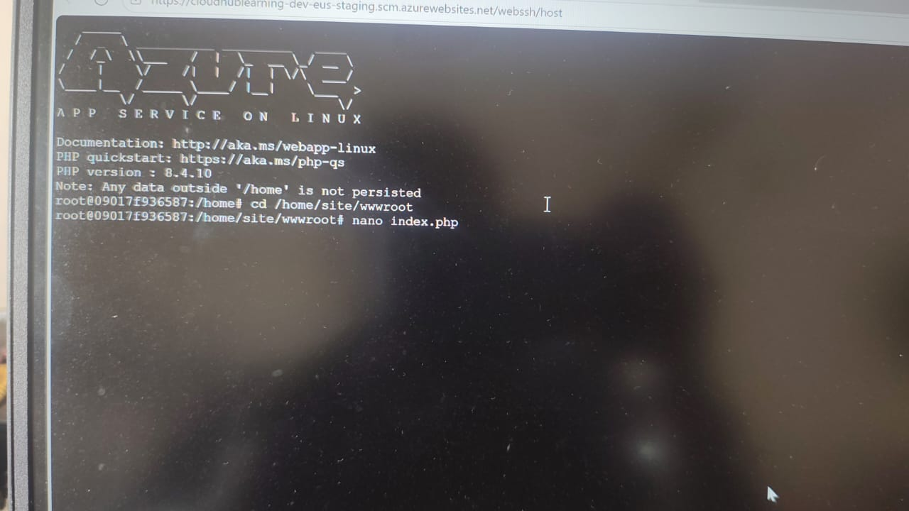
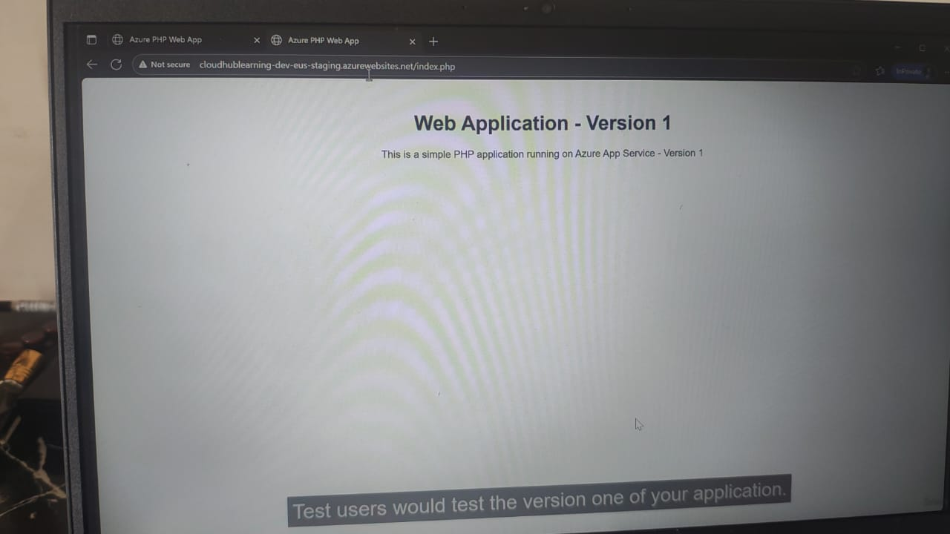
U can see the website.

2)what is deployement slot:-
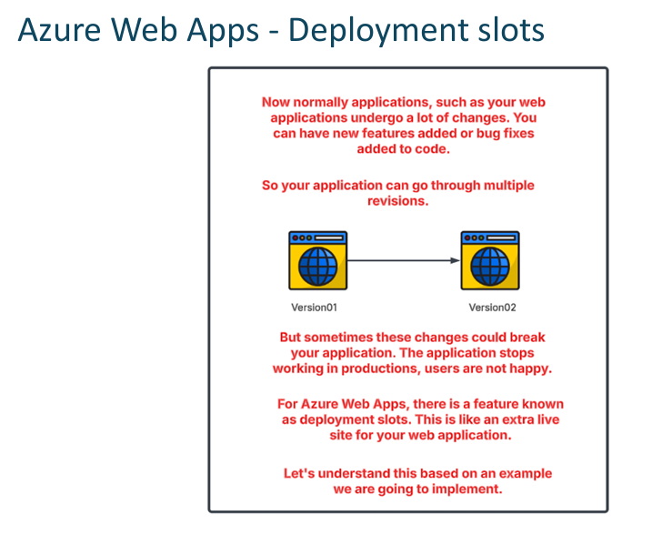

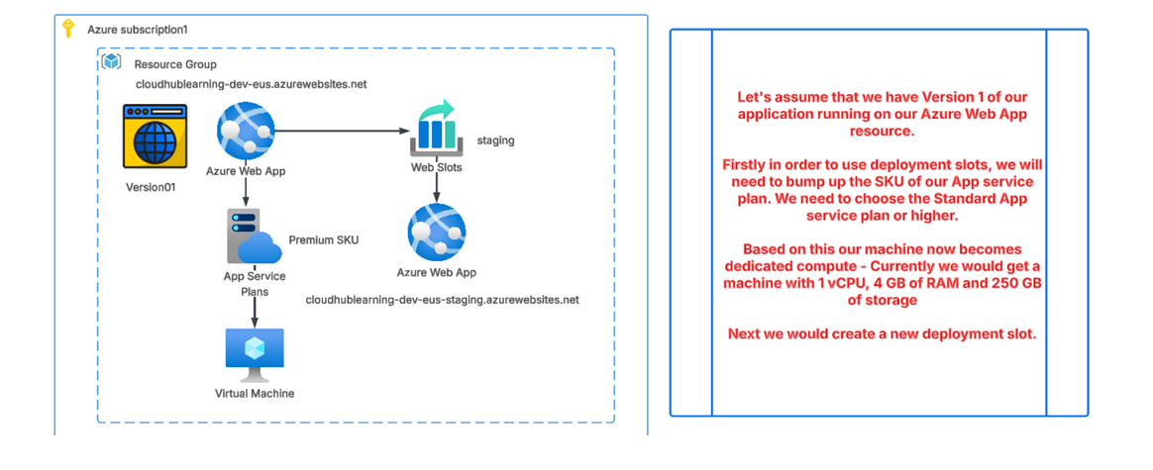

TO CREATE THE SLOT FOR APP WEB GOTO THE APP WEB-IEFT SIDE-DEPLOYMENT SLOTS=ADD SLOT-CLONE THE SETTING-ADD.
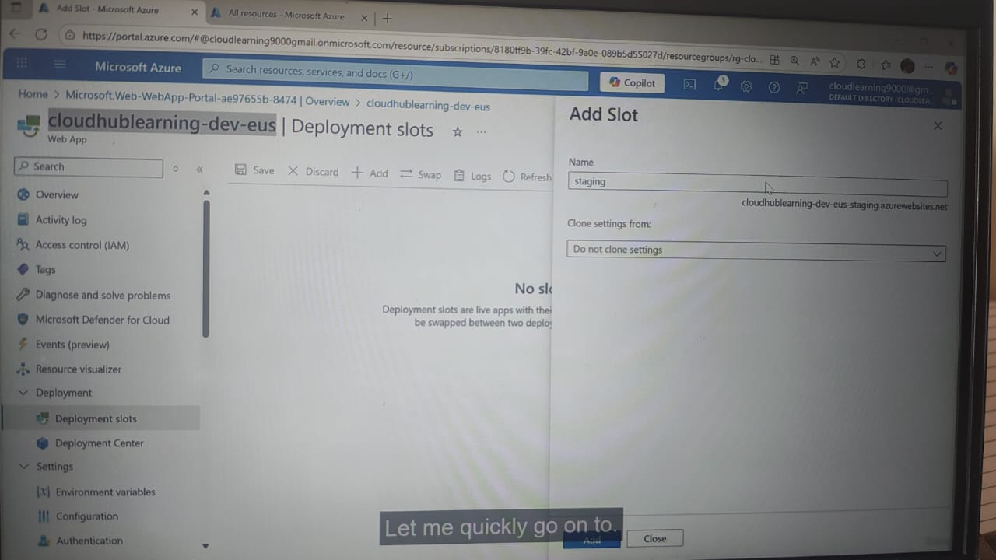
🔵 Settings You Can Clone in Deployment Slot
When you select Clone, Azure can copy:
✅ 1. App Settings
- Environment variables
- Connection strings
- Application configurations
✅ 2. General Settings
- Runtime stack
- Platform settings (32/64 bit)
- PHP/Java/.NET versions
- WebSockets, Always On, etc.
✅ 3. Authentication/Authorization Settings
- Identity provider configurations (Azure AD, Facebook, Google, etc.)
✅ 4. Monitoring Settings
- Application Insights
- Diagnostic logs
- Log level settings
✅ 5. Custom Domains / TLS Settings (optional)
Only if you choose them—usually not cloned by default.
❌ What is NOT cloned
Some things cannot be cloned:
- Custom domain names
- SSL certificates
- WebJobs
- Publishing profiles
- Virtual Network integration
- Private endpoints

🟢 In Short
Clone = Copy your app configuration settings to the new slot so it works the same as production, but isolated.

AFTER THAT YOUR SLOT AND NEW WEB APP IS READY NOW GO TO THAT AND ADD NEW WEBSITE THAT WE DONE EARILER. AND USING ITS DOMAIN NAME SEE YOUR WEBSITE.OLDER AND NEWNER.
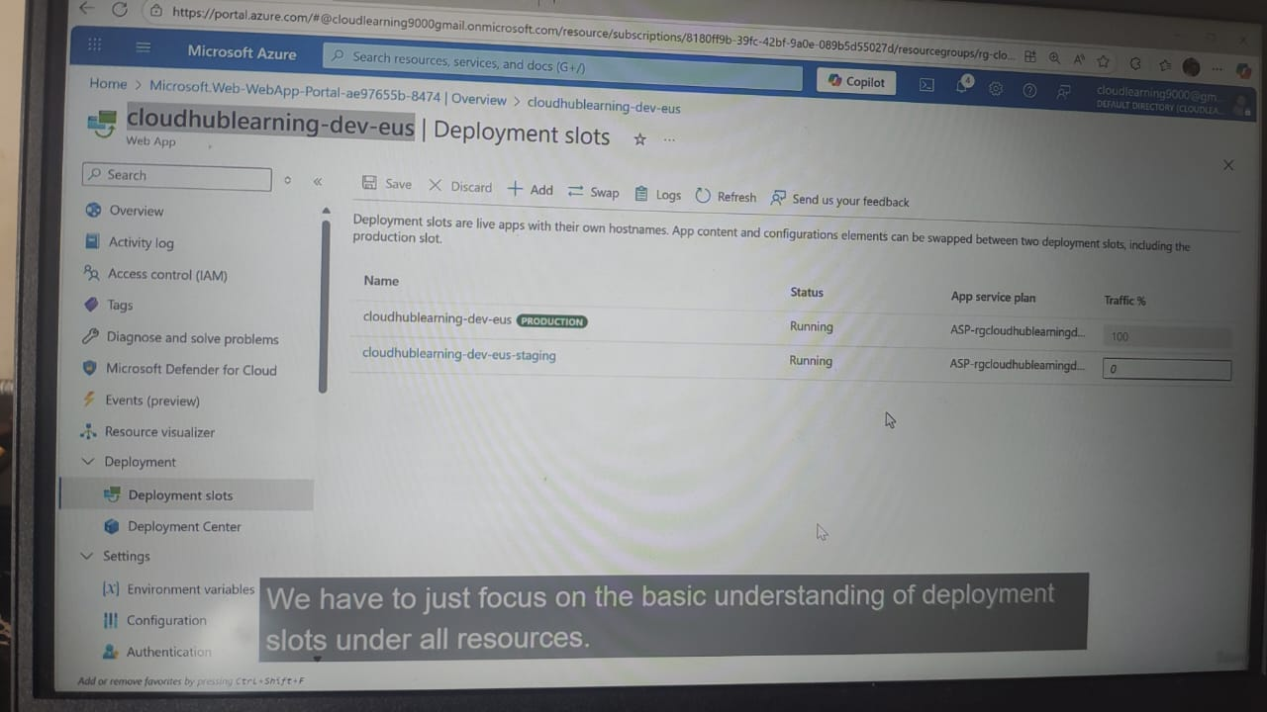

U CAN SWAP THE OLDER VERSION OF WEBSITE TO NEW WEBSITE:-CLICK ON SWAP:-
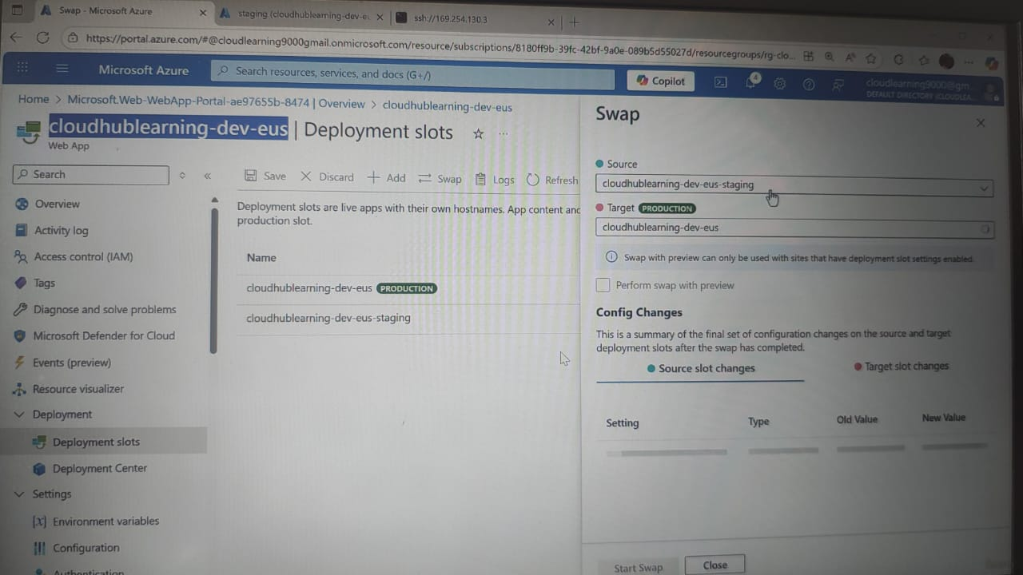
ADD SOURCE AND TARGET AND START SWAP.
Swap = change the app, NOT the DNS.
Users still visit the same URL, only the version of the app is switched.
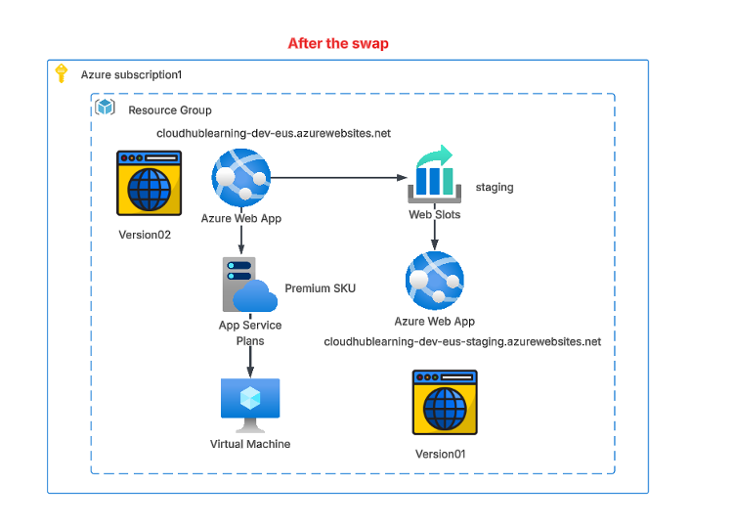

🔵 Scaling & Deployment Slots – Which App Service Plan Provides Them?
🟡 Scaling (Auto-scaling)
Auto-scaling is available from the Standard plan and above:
- ❌ Free → No scaling
- ❌ Basic → Manual scale only (no auto-scale)
- ✔ Standard → Auto-scaling available
- ✔ Premium → Advanced auto-scaling

🔵 Deployment Slots
Deployment Slots are available starting from Standard plan:
- ❌ Free → No deployment slots
- ❌ Basic → No deployment slots
- ✔ Standard → Deployment slots available (5 slots)
- ✔ Premium → More slots (up to 20)
TO SCALE THE WEB APP:-
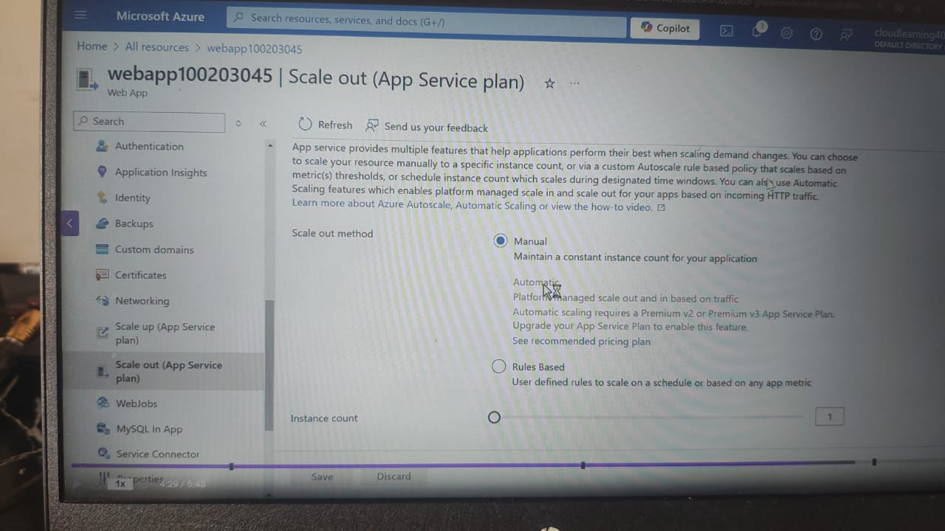
CLICK ON RULES BASED AND DO AUTO SCALING SAME AS VM SCALING.
IN STANDARD PLAN YOU CAN DO AUTO TO 10 SCALING WEB APP.

3)CONTAINER:-
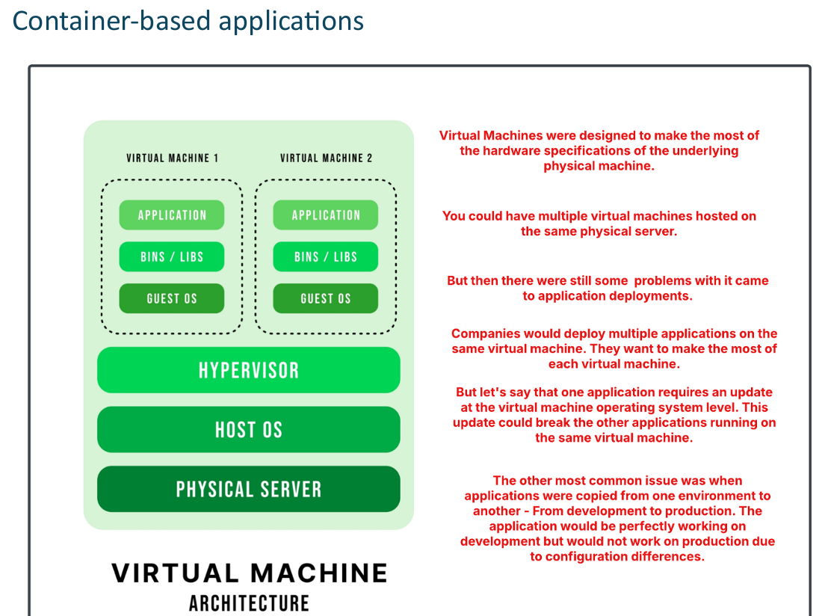

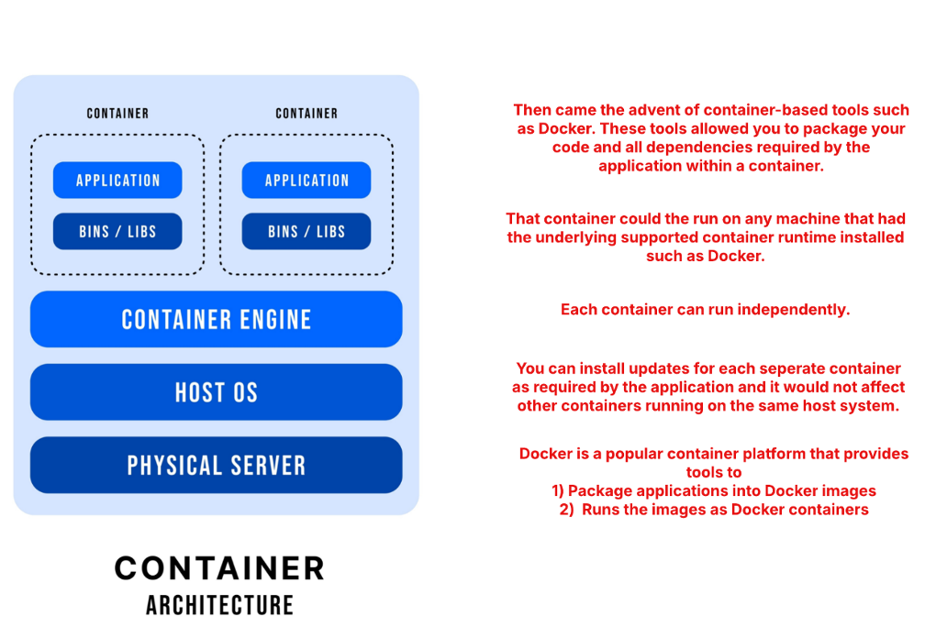
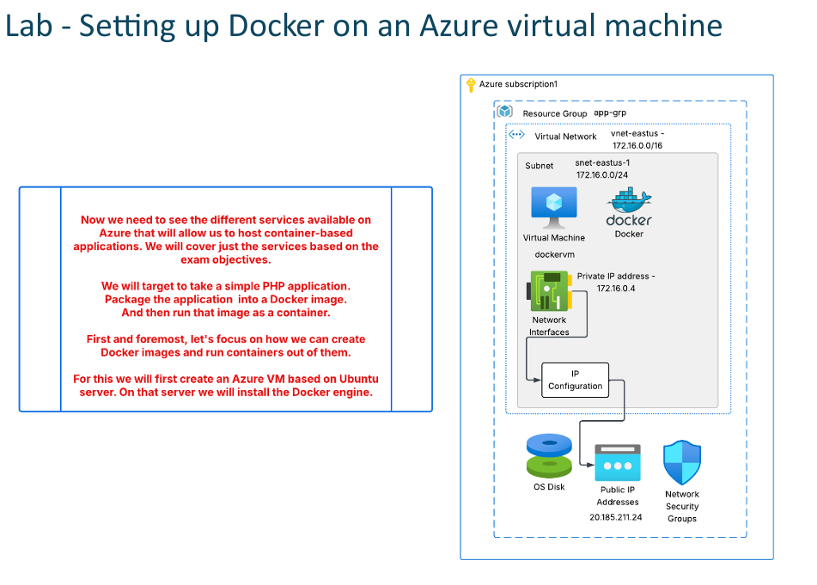

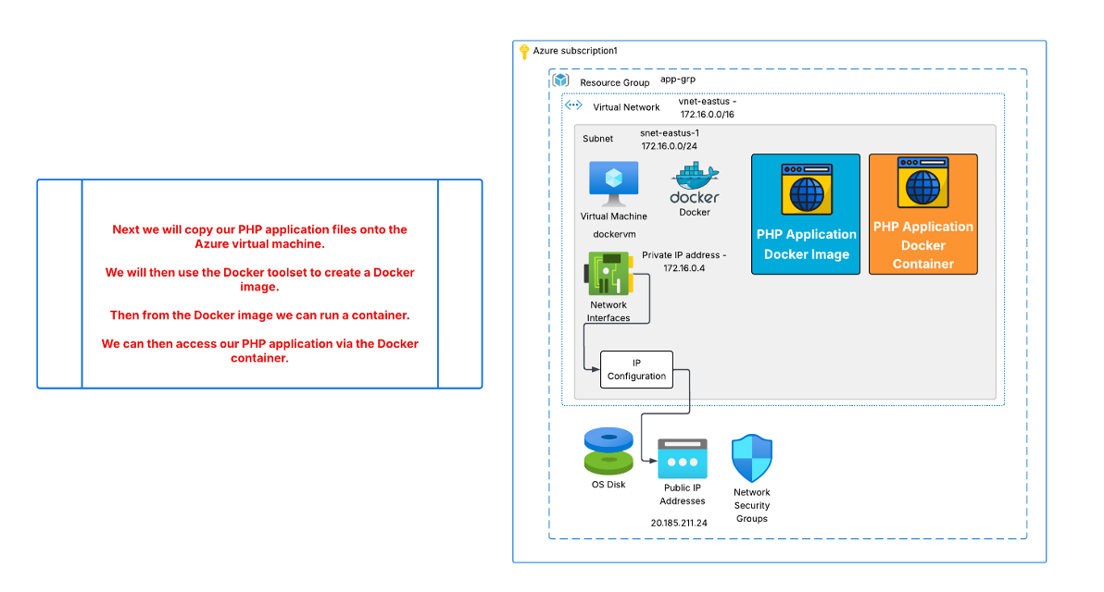
C:\Users\rohan\Downloads\phpapp.zip
AFTER THAT WE WILL CRETAE ONE VM AND IN THAT DOWNLOAD THE DOCKER CONTAINER,AFTER THAT WE CRETAE SIMPLE WEBSITE ON VS CODE, MAKE DOCKER FILE OF THAT.
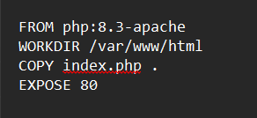

AFTER THAT WE USE CMD IN THAT WE DO SCP INDEX.PHP USERNAME@IP OF VM SAME WITH
SCP DOCKERFILE USERNAME@IP PF VM SO WE COPY THE BOTH FILE IN VM AFTER THAT IN VM CONSOLE SERIEL WE DO
LS
SO THERE WE CAN SEE THE VM IS APPERED,
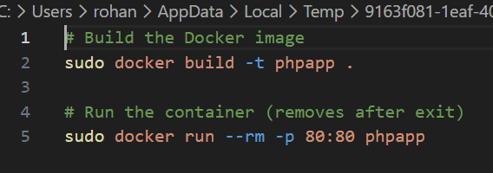
AFTER THAT WE WE CREATE THE IMAGES AND RUN THAT AND NIMD THE PORT AT 80 BEAUCE THE VM PORT IS OPEN BUT THE WEBSITE IS IN CONTAINER WHICH IOS NOT OPEN SO WE BIND THE VM 80 PORT WITH CONTAINER 80 PORT.USE IP OF VM TOO SEE THE WEBSITE ONLINE.
THIS IS HOW U CAN CRETAE THE DOCKERFILE AND SEND IT TO VM AND RUN THAT DOCKERFILE.

DOCKER CONTAINER REGISTRY:-
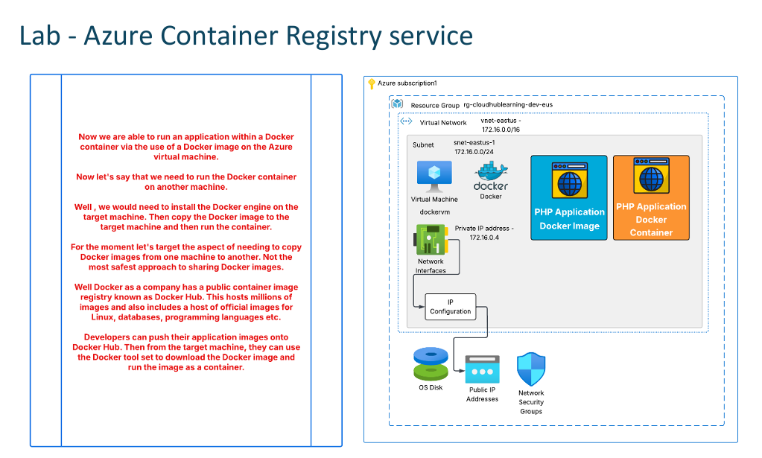

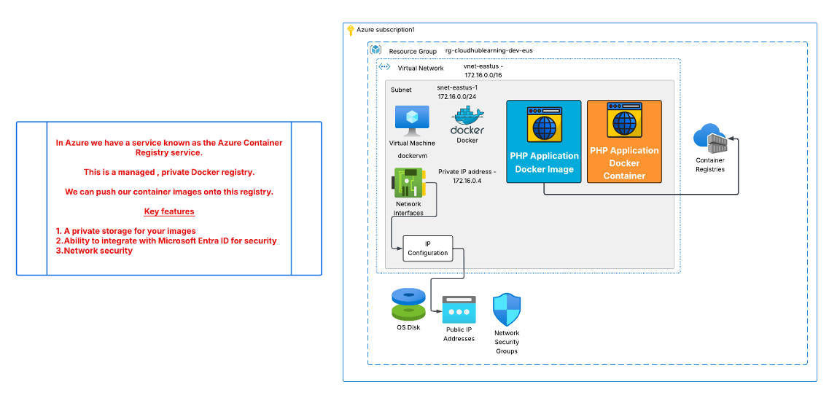
WE CRETAE THE AWS CONTAINER REGISTRY FROM AZURE PORTAL GO TO THE CONATINER-SERVICES-REPOSITORY

AFTER CREATING THAT GO TO THE ACCESS KEY TO CTEATE THE KEY TO PUSH THE IMAGE TO THE REGISTRY.
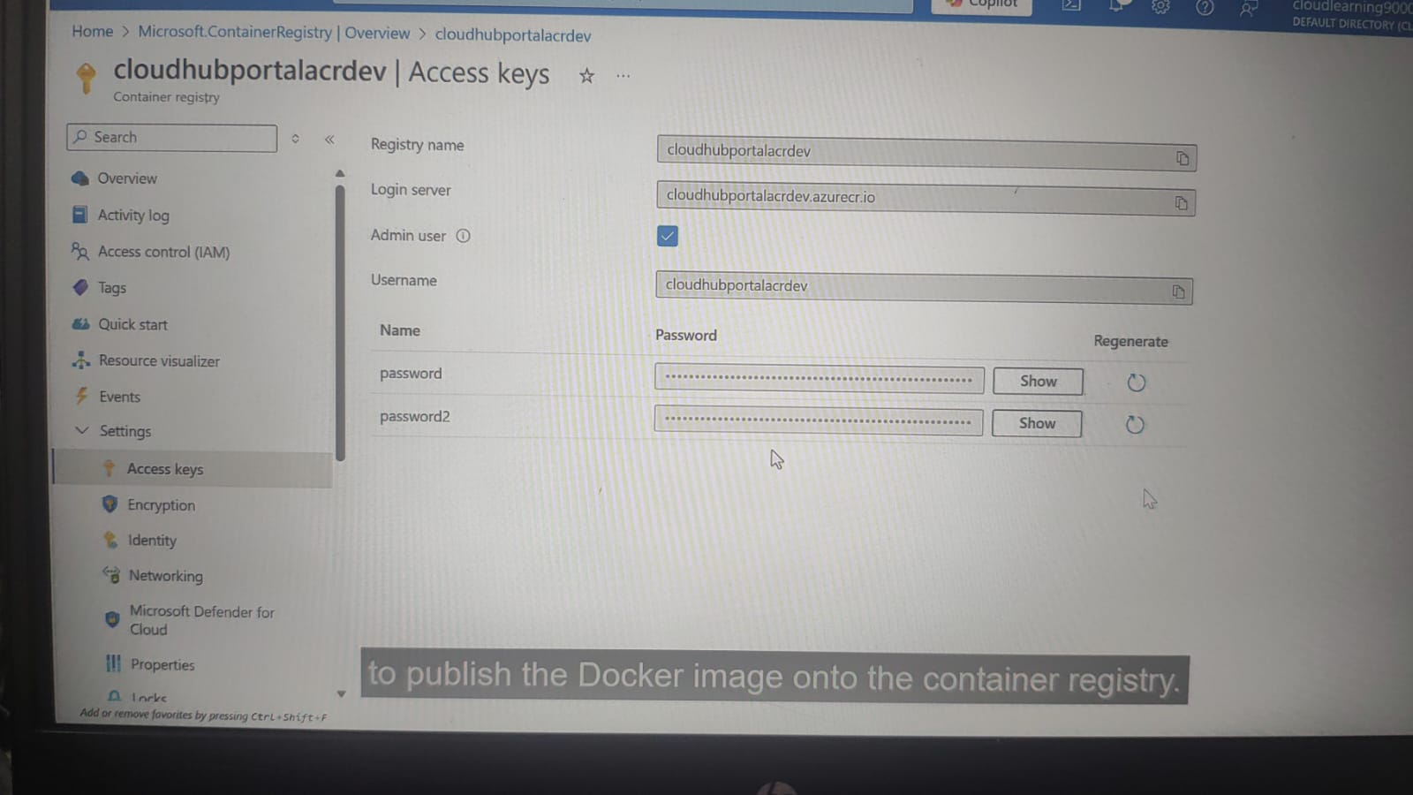
AFTER CRETAING THE ACCESS KEY USE BELOW COMMAND TO PUSH THE IMAGE.

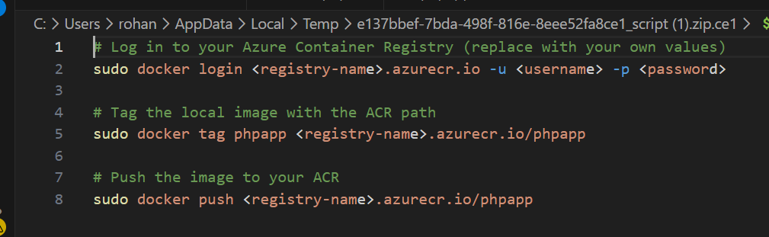
C:\Users\rohan\Downloads\script (1).zip
AFTER THAT WHEN U GO TO THE SERVICES-REPOSITORY THERE U CAN SEE THIS IMAGES.
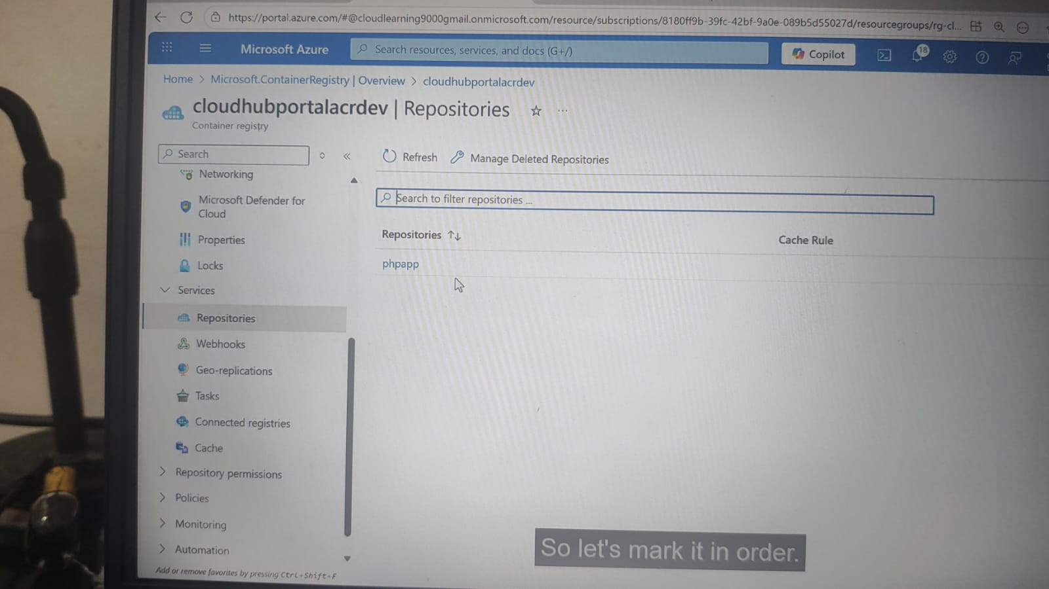

.
4) Azure Container Instances:=
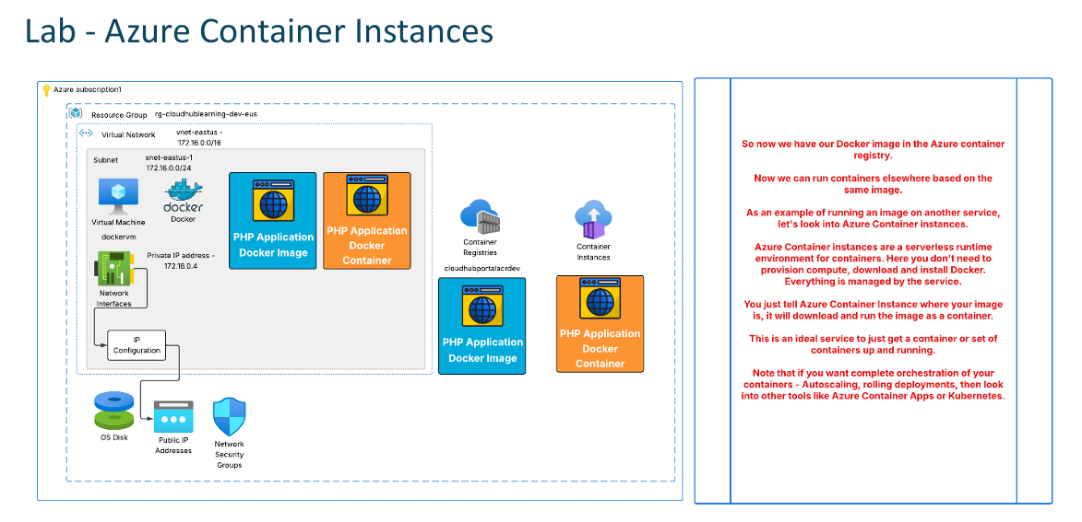
GO TO THE AZURE PORTAL- SEARCH CONTAINER INSTANCE
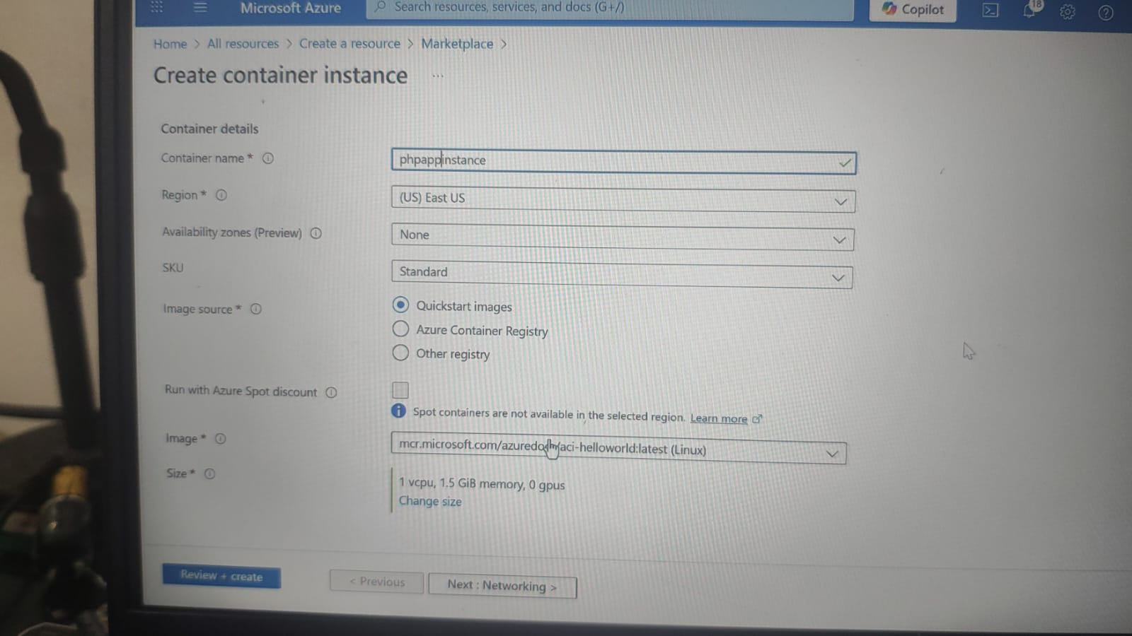
FROM CONTAINER REGISTRY IT WILL AUTOMATICALLY TAKE YOUR IMAGE IF U ENABLE THE ADMIN USER WHILE ACCESS KEY.

ENABLE PORT 80.
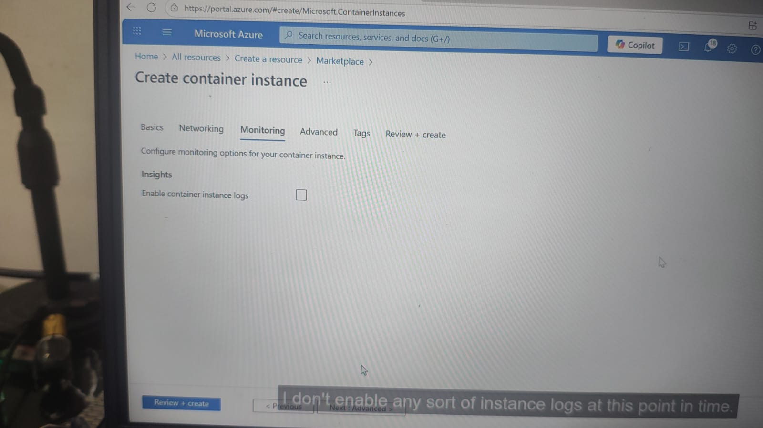
IF NOT NECESSARY DON’T TAKE LOGS.
AFTER THAT TAKE PUBLIC IP OF CONTAINER INSTRANCE AND BROWSE.

